CONAXIS – EXAMPLE 1

Modelling consolidation problem

# Problem description

We do an consolidation analysis for a column which has two layers. The column has radius 2.0m. The first layer (clay) has height of 1.0m and the second layer has height of 0.5m. Input parameters are give in Table 1.

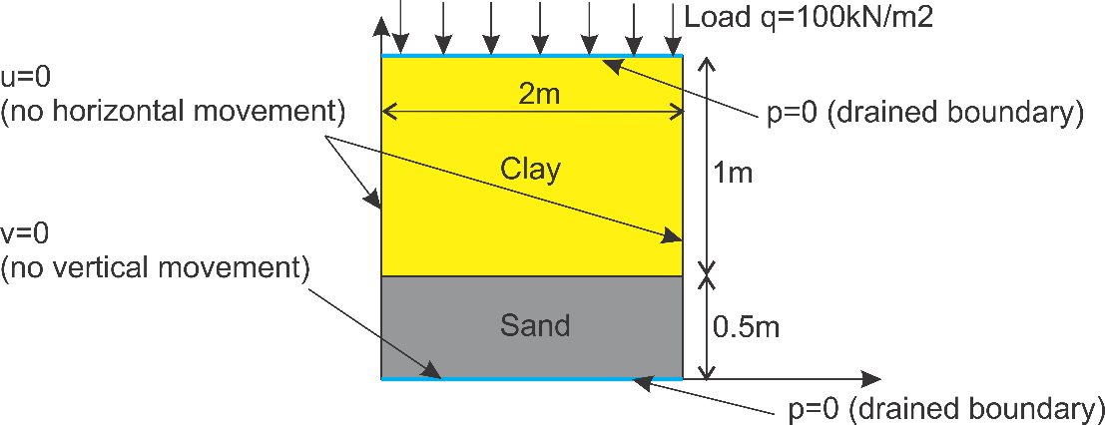

Figure 1: Problem scheme

Table 1: Input parameters

|  |  |  |  |  |  |
| --- | --- | --- | --- | --- | --- |
| Layer | Bulk modulus | Poisson’s ratio | Vertical hydraulic conductivity kv |  | Void ratio |
| Clay | 500 | 0.4 | 1e-9 | 2 | 1.8 |
| Sand | 5000 | 0.15 | 1e-5 | 1 | 0.6 |

The consolidation process lasts 10 day, with 100 sub-step (or the time step is 0.1 day). The column is fixed horizontally and is fixed at the bottom. The top and the bottom boundary are drained boundaries (excess pore pressure p=0).

For this problem, we need:

* Plot the final settlement
* Observe the change of excess pore pressure by using animation
* Get the excess pore pressure at the middle of clay (X=1, Y=1).

# Step 1: Create a mesh

Click *Geometry/Create mesh.*  A dialog pops out and we set the information as Figure 2. Click *Update* and then *Create mesh.* The final result looks like in Figure 3. If we want denser mesh, the number of sub-layer and the number of element for undisturbed zone can be modified.

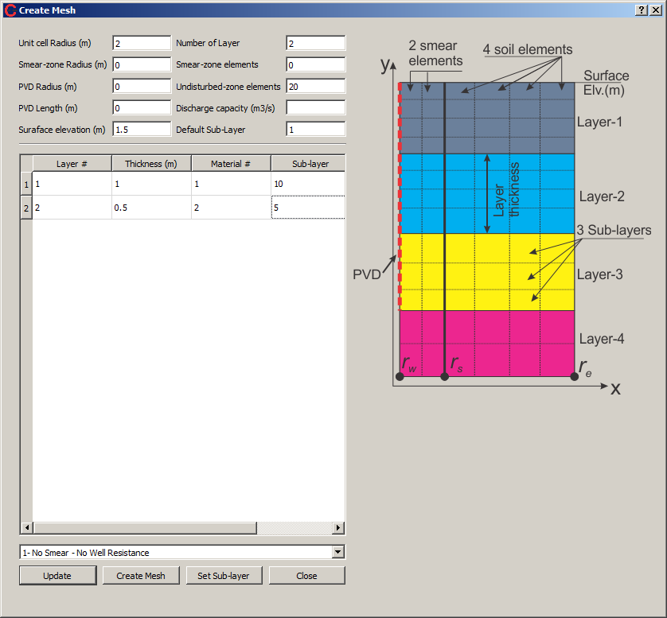

Figure 2: Creating the mesh

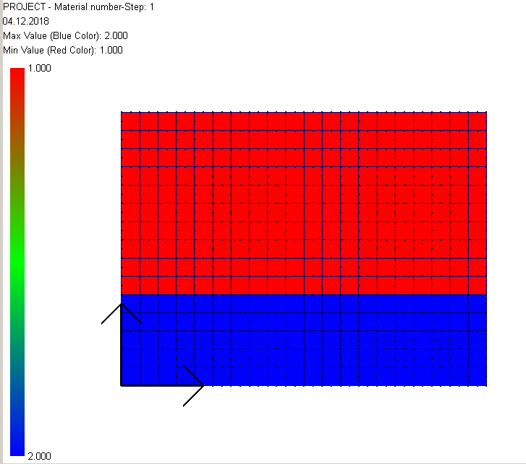

Figure 3: The final mesh

# Step 2: Create material

Click *Create Material* from the main toolbar. We create two materials as in Figure 4.

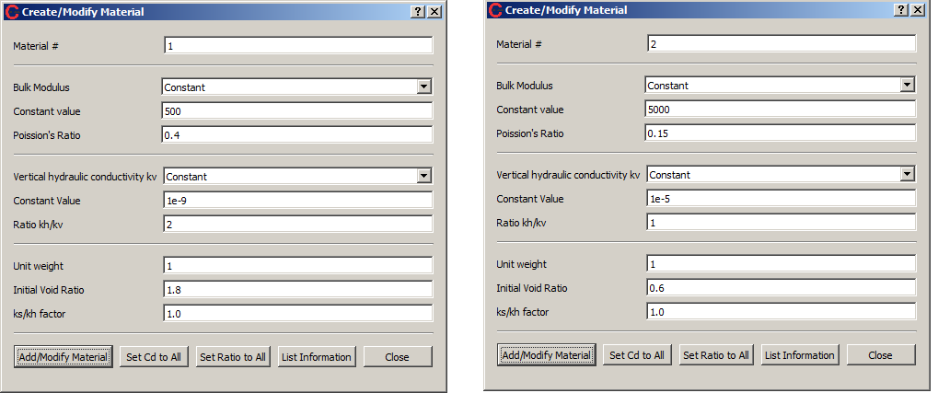

Figure 4: Creating material #1 and #2

# Step 3: Create analysis stages

For this problem, there are two analysis stages:

* **Undrained analysis:** To generate the initial excess pore pressure after applying load on the top.
* **Consolidation analysis**

Click *Stage* from the shortcut bar. We fill in information as Figure 5.

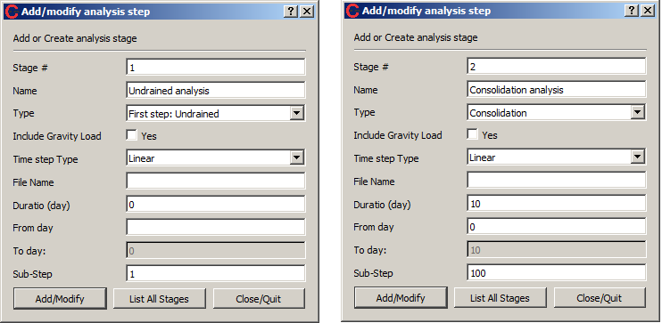

Figure 5: Two analysis stages

# Step 4: Create boundary conditions

Four boundary conditions are needed for this problem:

* No horizontal movement (BC1)
* No vertical movement (BC2)
* No excess pore pressure (BC3)
* Load on the top boundary (BC4)

To create boundary conditions, click *Boundary Condition/Add Boundary Condition.*

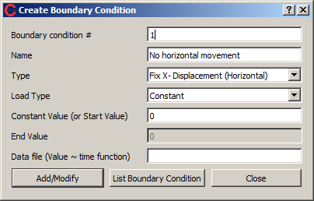

Figure 6: No horizontal movement

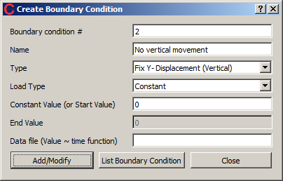

Figure 7: No vertical movement

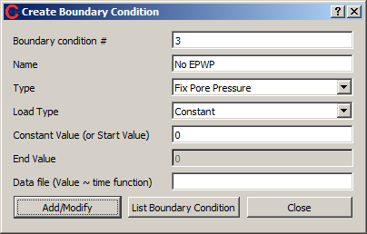

Figure 8: No excess pore pressure

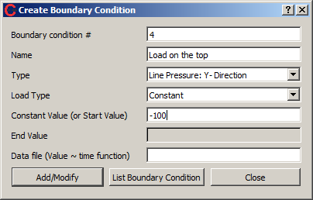

Figure 9: Load on the top boundary. The value is negative because the Y-direction is upward, while the load is downward.

# Step 5: Assign boundary conditions

We need to assign boundary conditions for each analysis stage. Click *Boundary Condition/Assign Boundary Condition.*

For the undrained analysis, there is no drained boundary. Hence, only BC1, BC2, and BC4 are applied to stage-1.

* BC1 is assigned for the left and the right boundary. The left boundary has x=0, y=0-1.5. The right boundary has x=2, and y=0-1.5.
* BC2 is assigned to the bottom boundary which has x=0-2, y=0.
* BC4 is assigned to the top boundary which has x=0-2, y=1.5

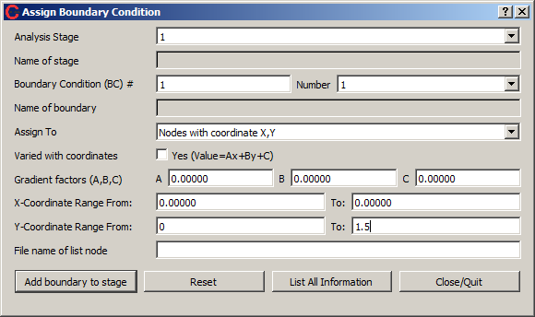

Figure 10: Assign BC1 to the left side

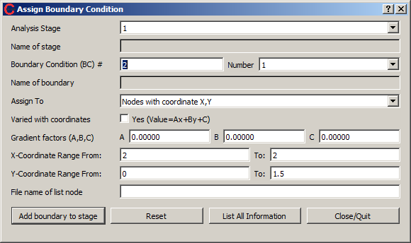

Figure 11: Assign BC1 to the right side

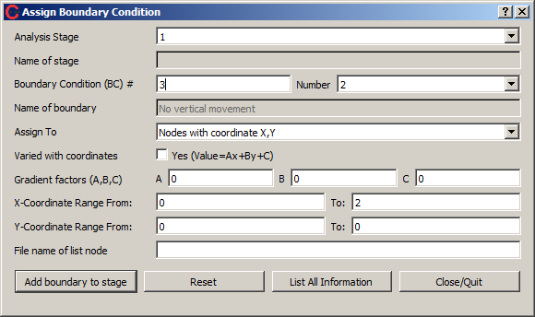

Figure 12: Assign BC2 to the bottom

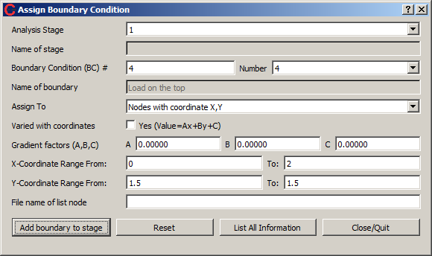

Figure 13: Assign BC4 to the top

After finishing with stage-1, we move to stage-2. The consolidation stage has almost same boundary conditions as stage-1, except adding the BC3 to the top. Hence, we copy boundary conditions from stage-1 and then add BC3.

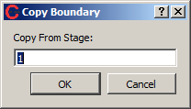

Figure 14: Copy boundary conditions from stage-1 to stage-2

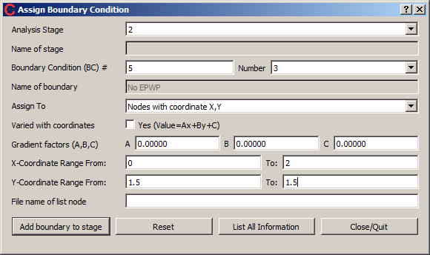

Figure 15: Add BC3 to stage-2

# Step 6: Define monitoring results

Since we want to get results of the EPWP of middle clay that has X=1, Y=1. We define a watch list as

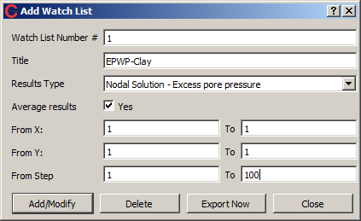

Figure 16: Defining a watch list

# Step 7: Run analysis and visualize results

All the pre-processing steps are done. To run analysis, just press *Run* from the shortcut bar, or Ctrl+R. Before running, save data to a specific folder. The data is saved under *.coa* extension.

To visualize the settlement at the final step, chose *Vertical Displacement* from the combo box of the left corner, click *Plot* from the shortcut bar, and fill 100 in the *Step Result* box (Figure 17).

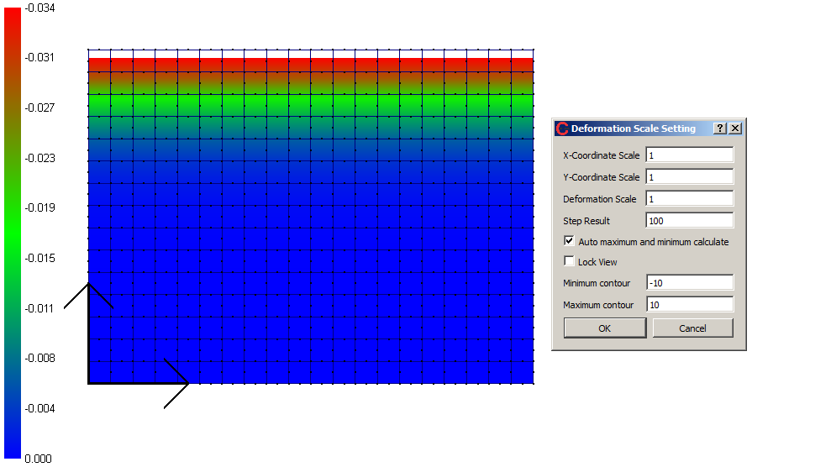

Figure 17: Final settlement

The EPWP at the final step is shown in Figure 18. To make an animation, click *Animation* from the shortcut bar and set parameters as Figure 19.

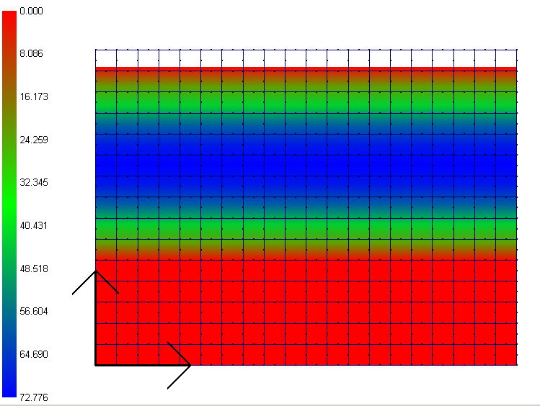

Figure 18: Excess pore pressure at the final step

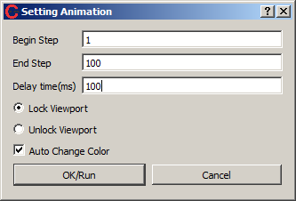

Figure 19: Creating an animation

The results at the middle of clay is saved under the file *EPWP-Clay.txt.*

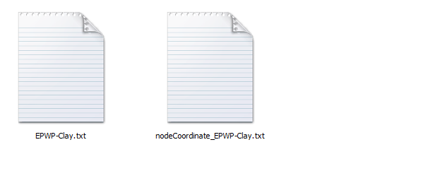

Figure 20: Watch list result